National College of Computer Studies

Paknajol, Kathmandu

**Report on**

**Virtual Reality**

**Submitted by:                                                 Submitted to:**

Samriddhi Shakya Dadhi Ram Ghimire

Programme: BCA 1st Semester                        TU Lecturer

Roll. No: 28

Email:[samriddhishakya617@gmail.com](mailto:samriddhishakya617@gmail.com)

**Abstract**

Virtual Reality is a three dimensional, computer generated environment which can be explored and interact with by a person. That person becomes part of this virtual world and is able to manipulate objects. This report basically provides the basics information about virtual reality. In Simple language, we can say that Virtual Reality is a way of visualizing, manipulating and interacting with computers for humans and also it is extremely complex data. This report contains the history of Virtual Reality. It talks about how the concept of Virtual Reality was started. Virtual Reality often used in the application that is based on 3D space for analyzing and in the visualization of overall physical dimensions. So, emergence of Virtual Reality contains different highlighted points whish were invented in different period of time. Similarly, here in this report there are many applications of virtual reality and talks about the different uses of VR in different sectors. There are mainly three type of Virtual Reality according to the different usage of technological supply. According to increasing and using the VR technology in many fields around the world, the tools and software to develop and use VR systems are available and still growing. So, the different components of VR technology are discussed in this report. In this way, it has included the information of Virtual Technology.

**Table of content**

1. Introduction……………………………………………………1

1.1 History of VR……………………………………………...1-2

1. Emergence of VR technology………………………………….2-4
2. Applications of VR…………………………………………….5-6
3. Types of Virtual Reality………………………………………..6-7
4. Components of VR technology…………………………………7-8
5. Working Mechanism of VR…………………………………….8-9
6. Concerns & challenges………………………………………….11-12
7. Future of VR……………………………………………………..12
8. Conclusion……………………………………………………….13
9. References………………………………………………………..14

**1. Introduction/Background**

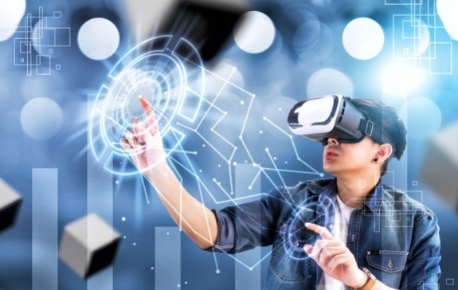Virtual reality is a way of visualizing, manipulating and interacting with computers for humans and also it is extremely complex data. Here the word visualizing refers to the computer generated outputs such as computer graphics, simulations and other such as the CAD models. The purpose of Virtual Reality is to allow a person to experience and manipulate the simulated environment as if it were the real world. Human can directly interact and manipulate with animations.

**1.1 Fig: Virtual Reality**

* 1. **History of virtual reality**

Virtual reality is described as an experience that includes sight, hearing and touch. It also represents an alternative to reality. Virtual Reality has been used in the private sector for a while but recently it has just become available to the more general public through a variety of devices for home use that have been released onto the market. Some people look at the panoramic paintings of the 1800s as the first attempt of Virtual Reality. Although they lacked the complete sensory displacement, but also panoramic paintings gave viewers an experience that they would not have received by looking at a flat piece of art with the help of the invention of electronics device were able to become more sophisticated in the early twentieth century. The first flight simulator which was a motion based device was created in 1329 by Edward Link which was also used in Train US military pilots in World War. Later, Mortor Heilig developed the sensoroma which was supposed to be a new movie watching experiences. In this way, 3D films movie came into practice. The Oculus Rift, which was released as a developer’s kit in 2013, which was considered as the first true virtual reality. Most of the current headsets available today for the consumers are geared towards the gaming community. However, these devices are being used more and more for educational purpose.

**2. Emergence of Virtual Reality Technology**

Virtual Reality often used in the application that is based on 3D space for analyzing and in the visualization of overall physical dimensions the emergence of VR can be highlighted the following main points.

**A.Sensoroma**

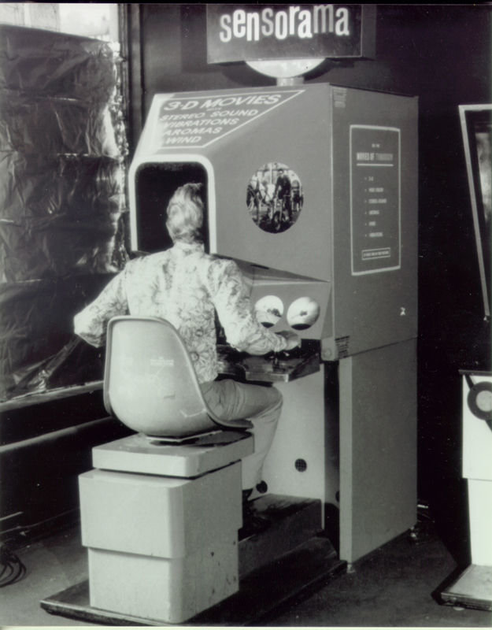Sensoroma was invented in 1957A.D by Morton Heilig. It is a machine modified in 1962. The system of sensoroma consisted of multisensory that could make a chromatic film that previously recorded o be presented by clear sound, smell, the wind and related vibration,

**1.2 Fig: Sensoroma**

**B.The Ultimate Display**

The Ultimate Display was invented by Ivan Sutherland in 1965A.D. Sutherland tried to suggest a definitive solution for the Virtual Reality. Its aim is to make system consists of interactive graphics with sound, smell and force feedback as the construction of an artificial world.

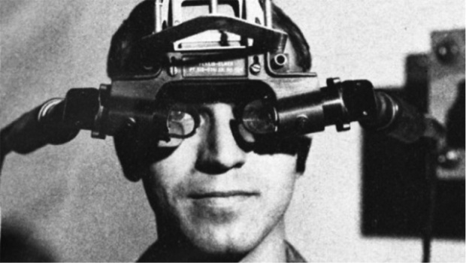

* 1. **Fig: The Ultimate Display**

**C.VIDEOPLACE**

VIDEOPLACE is a conceptual environment, which has no existence. It was invented by Myron Krueger in 1975 A.D. It was critically created to allow the image of users and the place in the scene of graphics. The user in this system can interact with other participants objects.

* 1. 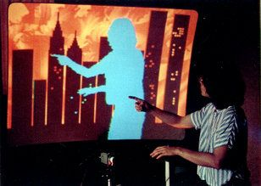**Fig: VIDEOPLACE**

**D.VIVED**

It is an abbreviation of ‘Virtual Visual Environment Display’ that created at NASA Ames with a stereoscopic monochrome. It was created to allow a person to describe his digital world for other people and see it as 3D space. It was created in 1984 A.D.

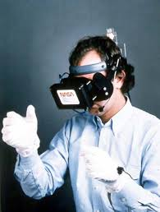**1.5 Fig: VIVED**

**E.CAVE**

It is a Virtual Reality and scientific visualization system. It was invented in 1992. It uses stereoscopic pictures on the walls of the room instead of using HMD. In his system, the user has to wear. LCD shutter glasses which were known as “active shutter glasses.”

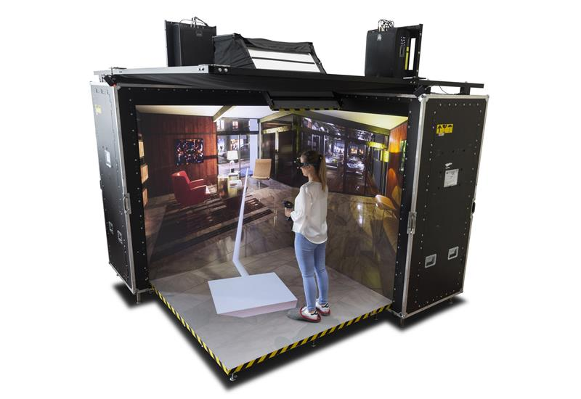

* 1. **Fig: HMD and CAVE**

**3. Applications of Virtual Reality**

Virtual Reality can be applied in any field to enhance performance of he system. It is very difficult to list all applications of VR. Some of the sample applications are described below:

**Military:** Virtual Reality is adopted in military for training purposes. This is particularly useful for training soldiers for combat situations or other dangerous settings where they have to learn how to react in an appropriate manner.

**Healthcare:** Healthcare is one of the biggest adopters of VR which encompasses surgery simulation, phobia treatment, skills training etc. One of the advantages of this technology is that it allows healthcare professionals to learn new skills as well as refreshing existing ones in a safe environment and it allows this without causing any danger to the patients.

**Fashion:** Virtual Reality is used in fashion shows for creating virtual fashion stores, Fashion show in second life, creating 3D fashion avatars etc. These games combine fashion, music and technology in a way designed to appeal to the interests of teenage girls.

**Business:** Virtual Reality is being used in a number of ways by the business community which includes virtual tours of a business environment, training of new employees, a 360 view of a product etc.

**Sports:** Virtual Reality is used as a training aid in many sports such as golf, athletics, cycling etc. It is used as an aid to measuring athletic performance as well as analyzing technique and is designed to help with both of these.

**Education:** Education is another area which has adopted VR for teaching and learning situations. For example, astronomy students can learn about the solar systems and how it works by physical engagement with the objects within. They can move planets, see around stars and track the progress of a comet.

**Entertainment:** The entertainment industry is one the most enthusiastic advocates of virtual reality, most noticeably in games and virtual worlds. But other equally popular areas include interactive exhibitions, galleries, Theatre etc.

**Engineering:** Virtual Reality engineering includes the use of 3D modeling tools and visualization techniques as part of the design process. This technology enables engineers to view their project in 3D and gain a greater understanding of how it works.

**4. Types of Virtual Reality**

The different types of the VR system are classified according to different usage of technological supply. The different types of VR system that use various technological devices and perform different function are shown through the following explanation.

**A. Immersive System (Fully-immersive)**

The immersion type of VR system requires the user to wear a data glove and HMD that tracks the user’s head movements that then changes the view. This type of technology is expensive and has some disadvantages, including less determining images, burden and environmental problems concerning simulators. The user has the ability of feeling of being part of the virtual environment. CAVE is an example of fully immersion technology.

**B. Non- Immersive System**

The non-immersive system is often called desktop virtual reality. It is based on the displayed screens as it is a window to the virtual world without additional device like HMD ( Head Mounted Display). These systems provide a lower level of presence and perhaps interaction but can achieve satisfactory levels of graphic quality, user comfort and convenience and lower costs. It is lower in cost and is the least sophisticated component which is mostly used in education. Example: Video games, 3D displayer.

**C. Semi-Immersive system**

It is the third type of VR systems which is also known as hybrid systems. It is a development desktop VR and include additional devices such as Data Gloves. In semi immersive, the displays virtual environment is set up onto the recognized real environment for building semi immersive system, the requirement is displaying, tracking sensor and user interfaces. The input to this types of system is entered and controlled by the users such as a mouse, keyboard intersection styles, glasses and joystick. Example off semi- immersive is projection screen.

**1.1 Table: Comparison among Fully immersive, Non immersive and Semi immersive**

|  |  |  |  |
| --- | --- | --- | --- |
| **Main Features** | **Fully Immersive System** | **Non Immersive System** | **Semi Immersive System** |
| **Resolution** | Low – medium  300-1000 | High resolution | High  1000-3000 |
| **Scale** | High | Low | Medium |
| **Navigational skills** | High | Low | Medium |
| **Field of regard** | High  360 degree | Low  50 degree | Medium  150 degree |
| **Immersion** | Medium - high | None-low | Medium- high |

**5. Components of VR technology**

According to increasing and using the VR technology in many fields around the world, the tools and software to develop and use VR systems are available and still growing. The software of VR technology has four main components that are” 3D modeling software, 2D graphics software, digital sound editing software and VR simulation software” according to Onyesoly.

**A. 3D modeling Software**

It is a program used to inspire 3D images using a computer and then build geometry object in VR environments. Examples of tools used in this components of software are Autodesk 3D Max, Gl Studio, Electric Image Animation System, Maya.

**B. 2D graphics software**

The 2D graphics software creates images, diagrams and manipulates it by using the mouse, graphics tablet or similar hardware. This types of software is also used in drawings such as electrical, electronic diagrams, topographic maps, and texts in a computer. It is a programs used to integrate the components of VR.

**C. VR Simulation Software**

It is 3D application server to create a 3D environment, it has many tools for developers to improve and build various applications such as chat applications among avators. An example of this simulations software is Open Simulator.VR Simulation Software is considered as scripting language similar to JavaScript.

**D. Digital Sound Editing Software**

This type of editing software is used to edit and mix sounds in VR environments with other objects available in the same environment. Examples of sound editing software are Audio book Cutter Free Edition, Creative Wave studio, Gold wave etc. In this component, VRML (Virtual Reality Modeling Language) can be used alone and viewed on a played or a viewer or onto a Web browser.

**Working Mechanism of Virtual Reality**

The earliest VR system “The Sensoroma” was able to display stereoscopic 3-D images in a wide-angle view, provides body tilting, supply stereo sound, and also had tracks for wind and aromas to be triggered during the film. But the inventor of Sensoroma “Heilig” was unable to obtain financial backing for his visions and patents, and so the Sensoroma work was halted.

Nowadays, most VR headset are made up of light weight plastic. Here, In Virtual Reality Headset plays a vital role in it. The headset opens and our devices sleep in right there. The Headsets works with any smart phones with the display size between 3.4 inches to 6 inches. Virtual Reality with headset are really comfortable panning at the front and at the back as well. The face blade in also attachable in it so we can have the access to the speaker and the camera on the smart phone which is connects to the headset that helps to capture your own 3D content with the cardboard camera application. The important role in VR headset that plays the main role is lens in it. The lenses makes a moving to demonstrate the object which looks like real world 3D. There in no need to download any app to have the feel of real world 3D. We can easily play any video we like to have the feel of real 3D world. After playing video we can type to VR logo option right there. Then the video starts moving with the motion of the phone which was possible only through gyroscopic sensor in every smart phone. After that once the smart phone is in the head set, the lenses in the head set helps to create three dimensional images of the content which is being display on your smart phone. As the lenses are super wide in angle, so no mater wherever you are looking and or moving your eyes too. You are going to only see the 3D area in the smart phone. Now the sensor of your smart phone starts tracking your head which gives alter realistic three dimensional space which moves depending on the movement of your head. But some other VR headset doesn’t work like this. The Virtual Reality like Ante VR and Gear VR Headset works quite differently. They need separate VR app to give the feeling of 3D real world to the viewers. 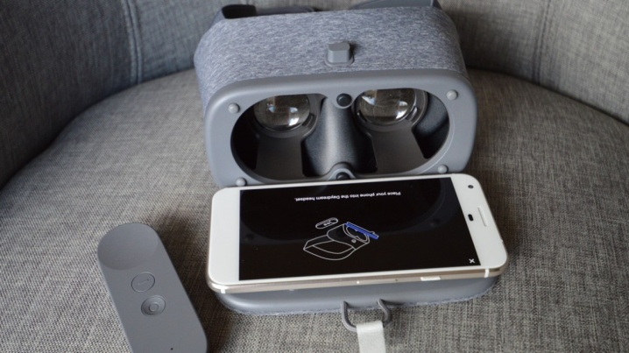Hence, in this way VR with headset works to create and to visualize the 3D real World.

* 1. **Fig: VR – Headset**

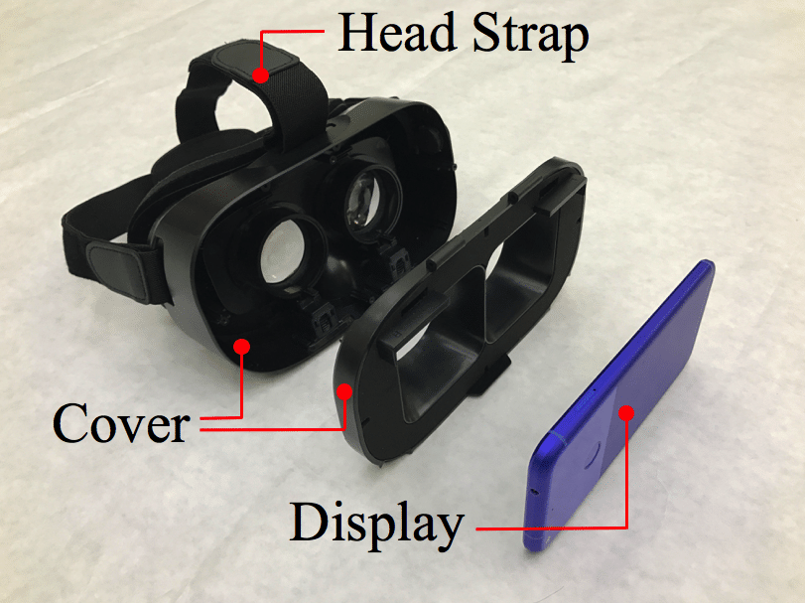

* 1. **Fig: Structure of VR- Headset**

**1.2 Table: Comparison of General Characteristics of VR Headsets**

|  |  |  |  |  |  |
| --- | --- | --- | --- | --- | --- |
| **Features** | **Google Cardboard 2.0** | **Oculus Rift** | **HTC Vive** | **Samsung HMD Odyssey** | **Hololens** |
| **Company name** | Google | Facebook | HTC | Samsung | Microsoft |
| **Initial cost** | $15 | $399 | $499 | $499 | $3000 |
| **Type** | With Mobile Phone | Headset with a PC | Headset with a PC | Headset with a PC | standalone |
| **Platform** | Android,  iOS | Oculus Home | Vive Port | Windows Mixed Reality | Windows 10 |
| **Resolution** | Smartphone Resolution | 2160 × 1200 | 2160 × 1200 | 2880×1600 | 1268×720 |
| **Display type** | Smartphone Display | OLED | OLED | AMOLED | See through holographic lens |
| **Field of view** | 90 degree | 110 degree | 110 degree | 110 degree | 35 degree |
| **Sense of immersion** | Medium | Medium- High | Medium-High | Medium-High | Low |
| **Multiple Concurrent Users** | No | Yes | Yes | Yes | Yes |
| **Controller** | Magnet | Oculus Touch | Vive Controller | HMD | Gaze, Gesture, voice |

**7. Concerns and challenges of Virtual Reality**

**7.1 Health and Safety**

There are many health and safety considerations of virtual reality. A number of unwanted symptoms have been caused by prolonged use of virtual reality and these may have slowed proliferation of the technology. Most virtual reality systems come with consumer warnings, including: seizures; developmental issues in children; trip-and-fall and collision warnings; discomfort; repetitive stress injury; and interference with medical devices. VR headsets may regularly cause eye fatigue, as does all screened technology, because people tend to blink less when watching screens, causing their eyes to become more dried out. There have been some concerns about VR headsets contributing to myopia, but although VR headsets sit close to the eyes, they may not necessarily contribute to nearsightedness if the focal length of the image being displayed is sufficiently far away.

[Virtual reality sickness](https://en.wikipedia.org/wiki/Virtual_reality_sickness) (also known as cyber sickness) occurs when a person's exposure to a virtual environment causes symptoms that are similar to [motion sickness](https://en.wikipedia.org/wiki/Motion_sickness) symptoms. Women are significantly more affected than men by headset-induced symptoms, at rates of around 77% and 33% respectively.

**7.2 Child in Virtual Reality**

The relationship between virtual reality and its underage users is controversial and unexplored. In the meantime, children are becoming increasingly aware of VR, Studies show that young children, compared to adults, may respond cognitively and behaviorally to immersive VR in ways that differ from adults. VR places users directly into the media content, potentially making the experience very vivid and real for children. For example, children of 6–18 years of age reported higher levels of presence and "realness" of a virtual environment compared with adults 19–65 years of age. Experiencing VR by children may further involve simultaneously holding the idea of the virtual world in mind while experiencing the physical world. Excessive usage of immersive technology that has very salient sensory features may compromise children's ability to maintain the rules of the physical world, particularly when wearing a VR headset that blocks out the location of objects in the physical world. Immersive VR can provide users with multisensory experiences that replicate reality or create scenarios that are impossible or dangerous in the physical world.

### 7.3 Privacy

The persistent tracking required by all VR systems makes the technology particularly useful for, and vulnerable to, mass [surveillance](https://en.wikipedia.org/wiki/Surveillance). The expansion of VR will increase the potential and reduce the costs for information gathering of personal actions, movements and responses. Data from [eye tracking](https://en.wikipedia.org/wiki/Eye_tracking) sensors, which are projected to become a standard feature in virtual reality headsets, may indirectly reveal information about a user's ethnicity, personality traits, fears, emotions, interests, skills, and physical and mental health condition.

### 7.4 Conceptual and philosophical concerns

In addition, there are conceptual and philosophical considerations and implications associated with the use of virtual reality. What the phrase "virtual reality" means or refers to can be ambiguous. Mychilo S. Cline argued in 2005 that through virtual reality, techniques will be developed to influence human behavior, [interpersonal communication](https://en.wikipedia.org/wiki/Interpersonal_communication), and [cognition](https://en.wikipedia.org/wiki/Cognition).

**8. Virtual Reality in future**

VR technologies will make smart phones smarter, and many more smart tools like VR goggles, VR devices will flood the market. With VR, we can enjoy history (which is boring theoretically), can explore the space (from Earth), can see the surface of the moon in 3D and much more. So naturally we expect VR to be a big part of our future. With so much investment of time, workforce and money in this technology, expectations has increased and there are the some ways in which VR can affect us and can change our future like gaming, travelling, working with more comfort, etc.

**Conclusion**

Virtual Reality was definitely invented to feel the real 3D world. Many people are having fun by using Virtual Technologies. Although VR devices have improved over the years, it still has a long way to go before it stops being science fiction and becomes embedded in society. Although compared to the number of smart phone users, this number is quite small. But considering how recently this technology is moving into mainstream consumerism, this level of growth is outstanding. VR technology is still in its infancy and we are not yet sure how full scale VR invasion will impact our social lives. Teenage internet addiction is really high which even has internet rehabilitation centers to combat this problem. Similarly when VR becomes accessible by majority of the population, it should not end up becoming a social problem. So due diligence will have to be taken by the respective stakeholders, including manufacturers of VR technology, VR content providers, manufacturers that use VR to attract customers, governments and the people themselves.

In a nutshell. I would like to conclude that VR technology can be used for many purposes but it shouldnot be used unlimitedly because there may be many sight effects of using it unlimitedly.

**References**

[1] “Introduction / Background” and “History of Virtual Reality” Retrived from:

<https://journals.ala.org/index.php/ltr/article/view/6778/9115>

[2]”emergence of Virtual Reality” and “components of Virtual Reality”Retrived from:

https://www.researchgate.net/publication/2617390_Virtual_Reality_-_History_Applications_Technology_and_Future

[3]”Applications of VR” Retrived from:

<https://www.vrs.org.uk/virtual-reality-applications/>

[4] “Types of Virtual Reality” Retrived from:

Dr Naji Shukri Alzaza

[5] “Concerns and challenges” Rerived from:

<https://en.wikipedia.org/wiki/Virtual_reality>

[6] “Virtual reality in Future” Retrived from:

<https://www.lifehack.org/507669/7-ways-virtual-reality-will-change-the-future>